Leonardo Carer Support

5 Dunyeats Road
Broadstone, Dorset
BH18 8AA
t: 01202 698325
e: info@leonardocarersupport.org
In Partnership with
Office use only
Date Received:

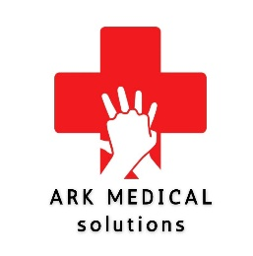
Carers First Aid Workshop Course Application Form

Carers details:
Name of Carer:
Address of Carer:
 |  |  |  |  | Postcode:
Tel No: |  |  | Mobile No.
Email:
Date of Birth: |  |  | How long have you/they been a carer?
Name of person cared for:
Their age:
Relationship to the carer:
Please state which venue you would like to attend.
Where did you hear about the course?
Would you prefer the AM or PM session?

I understand that all information supplied on this application form to Leonardo Carer Support will be kept strictly confidential and will only be used for the purpose of administration. I understand that this information will be shared with Ark Medical Solutions for the administration of the course.

Name of person completing the form | Nicky Stafford | Date

